The Software Development Life Cycle Group Project

User Interface Design
Author(s) | Adrian Gawryszewski  James Barnett  Samuel Clements  Stoyko Veselinov Kodzhabashev
Configuration Reference | Unknown
Last Updated | 31/10/12
Version Number | 1.2
Document Status | For Review
Department of Computer Science
Aberystwyth University
Aberystwyth
Ceredigion
SY23 3DB

Copyright © Aberystwyth University 2012-13
Table of Contents
1 INTRODUCTION 3
1.1 Purpose of this document 3
1.2 Scope 3
1.3 Objectives 3
2 DOCUMENT CONTENT 4
2.1 Account management 4
2.1.1 Register/Unregister 4
2.1.2 Login/Logoff 4
2.2 Offers 5
2.2.1 Friend Requests 5
2.2.2 Fight request 5
2.2.3 Breed 5
2.2.4 Trade 5
2.2.5 Notifications 6
2.2.6 Accept an offer 6
2.3 Other Views 7
2.3.1 Home Screen 7
2.3.2 View Friends Monsters 7
2.3.3 Profile View 8
2.3.4 Choose a monster 9
3 REFERENCES 9
4 DOCUMENT CHANGE HISTORY 9

INTRODUCTION

Purpose of this document
This document describes the user interaction design for the The Software Development Life Cycle Group Project.

Scope
This document covers the possible interactions a user may have with the end product.

Objectives
The objectives of this document are to:
- Describe all possible user interactions with the end product, without any reference to technical aspects of the product.

DOCUMENT CONTENT

Account management
When a user starts playing the ‘Monster Mash’ game, they will first have to register and then login in order to start playing. The homepage for the game will display options for the user to provide a email and password to login, or a button to register.

Register/Unregister
The first step you need to make in order to play the game is to create an account. When you click on the “register” button, you will be taken to another page where you will be able to fill in your information, including an email and password. When this has been filled in, the user will be able to click a button at the bottom of the page to continue. A page will then be displayed telling the user if the action was successful or not.
Users can remove their account with the “unregister” button. You will be asked to enter your email and password, and then press “unregister” again. Again, a page will then be displayed telling the user if the action was successful or not.

Login/Logoff
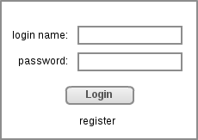
A login form will be displayed on the homepage. The user will need to enter the correct account details, and will then be taken to their account page. If the account details are incorrect, they will be returned to the home page and shown a message explaing this. Underneath the form will be an option to register.

Once the user has logged into their account, they will be able to see a logoff button. Pressing it will immediately take them out of the game and back to the home page of the game.

Offers
There are serveral types of user interation that can be described in terms of “offers”, where one user offers a request to another user, who then has the chance to either accept or reject the offer. There are four interactions that work this way:

Friend Requests
It sends “add friend” request to another user on a server (present server or any other server). If a request is accepted, new friend is added to our friend list. Otherwise any action isn't taken.

Fight request
Sends fight request to another player from our friends list. (You have to specify amount of money you want to bet, monster you have picked). Your opponent has to accept your offer, otherwise any action won't be taken. If accepted monsters proceed to fight. After the fight a winner receives money reward and both sides receives experience points.
As a result of any fight your monster can be injured or die. Injury may reduce the monsters attributes, and death will remove it from the owners list of owned monsters.

Breed
Sends breed request to another user from your friends list. You have to pick a monster you want to offer to breed and pick a monster from your friends list. If your offer is accepted new monster is created (his attributes depends on his parents attributes ). Otherwise nothing happens.

Trade
This interaction can occurs in three different cases:
- You may want to buy your friends monster. In this case you offer specified amount of money (I assume that every monster has it own value). If accepted, then monster is transferred to your monster farm and the other side receives payment.
- You may want to swap monsters with your friend. In this case you pick monsters you want to swap. If your offer is accepted, replacement occurs.
- You may want to sell your monster in order to get extra money. In this case you post your offer with a price. Request is sent to all users on your friends list. If any of them accepts your proposal sale occurs. Monster is transferred to your friend's farm and you receive payment.

Notifications
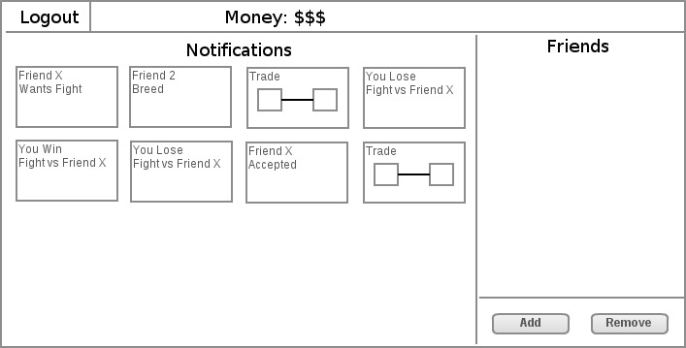
Once people have made offers to you, they will appear on the notifications page. Clicking on an offer will take the user to the 'Accept offer' page.

Accept an offer
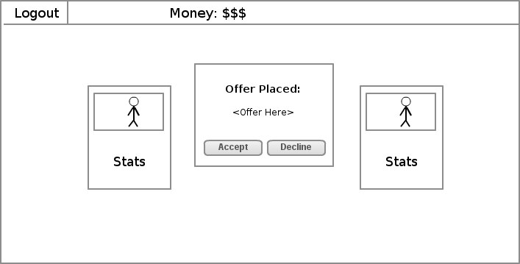
A user can select an offer, which will then show this screen, displaying details of the offer to be accepted. The details will be based on wether the offer is a friend request, or a monster trade/breed/fight. Either the friends or the monsters involved will be shown on the left and right, as a small card containing their stats. In the center will be buttons to accept and reject the offer.

When the user continues, they will be taken back to the previous page and shown a message telling them that the offer has been accepted or rejected.

Other Views

Home Screen
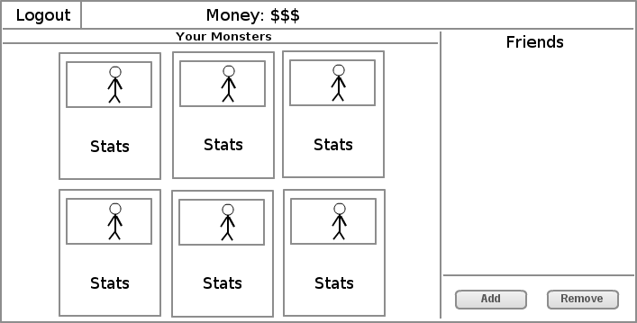
From the main home screen you can see a panel of your monsters, a list of your friends on the far right and an option to add and remove friends. You can also logout using the logout button at the top left corner. The money you currently have is displayed at the top.

View Friends Monsters
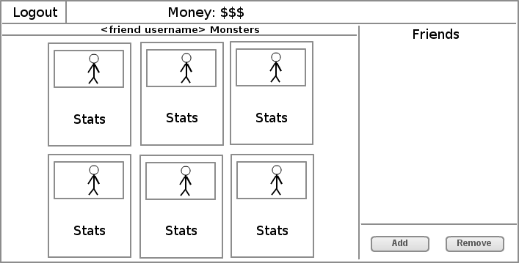
On this page will be a status bar that will tell you the username of your friend so you know you are on the right page. Below that you will see the main panel which will display the monsters that your friend has and the stats for each monster. On the far right will be a list of friends and an option to add and remove them.

Profile View
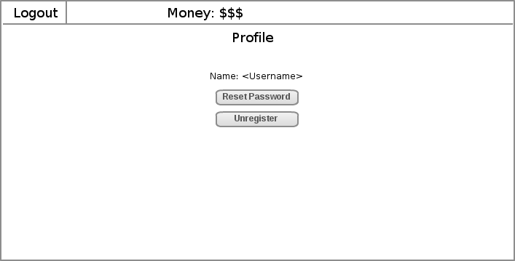
On this page you can see your username and two buttons. One button gives you the option to reset your password whereas the other is to unregister. You can also logout using the logout button at the top left corner.

Choose a monster
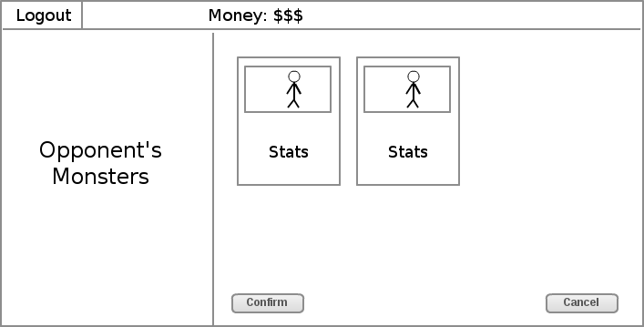
On this page you will see a logout button in the top left corner. Below that in the left panel you will see a message telling you that you are viewing your opponent’s monsters. On the right side is now the main panel which will display a monster to select for fighting, buying or breeding. In the main bar at the top you will see the money you currently have and at the bottom will be two buttons. One will be ‘confirm’ to carry through an action whereas the other will be ‘cancel’ to go back to the main screen.

REFERENCES
This section is an automatic bibliography.

DOCUMENT CHANGE HISTORY
Version | CCF No. | Date | Sections changed | Changed by
1.1 | N/A | 31/10/12 | Corrected document to be inline with the General Documentation Standards | Samuel Clements
1.2 | N/A | 08/11/12 | Corrected title | Samuel Clements

